Silhouette metric for img016001.jpg is: 0.9816585324472646

Davies Bouldin metric for img016001.jpg is: 0.016149099952772427

Calinski Harabasz metric for img016001.jpg is: 85557.81280772774

ID 0: (1682, 699)

ID 1: (435, 1057)

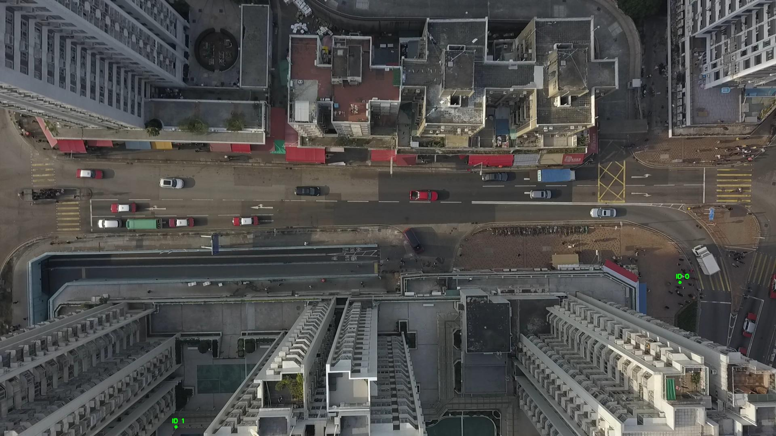

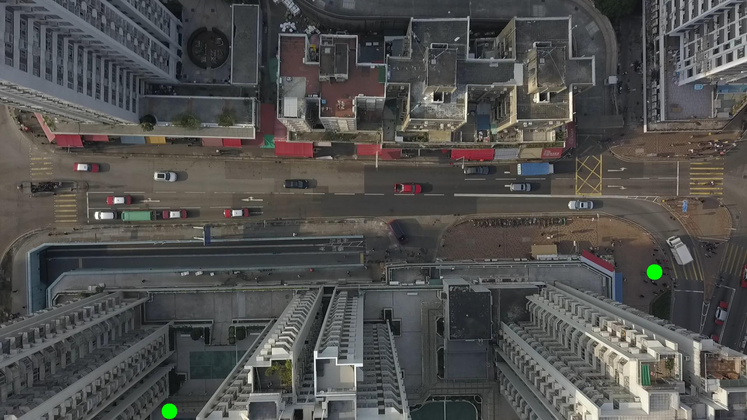

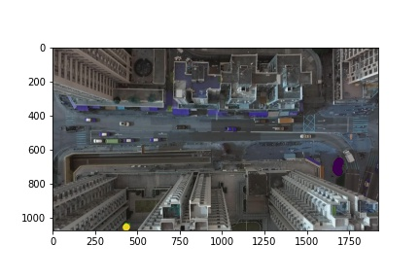

Metrics are not computable for img016002.jpg with bg_tresh: 0.5

ID 0: (1682, 698)

ID 1: (435, 1057)

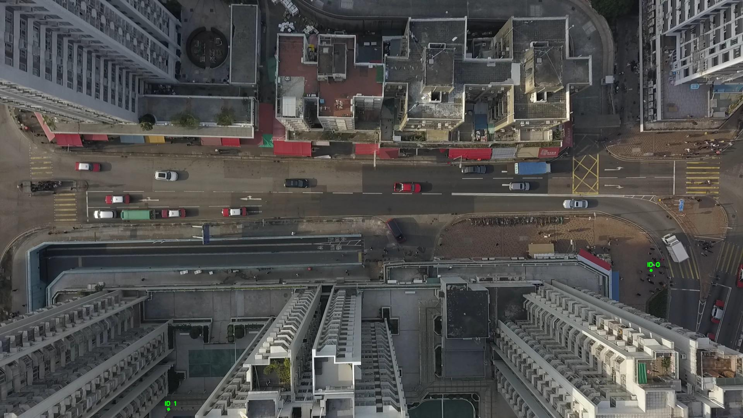

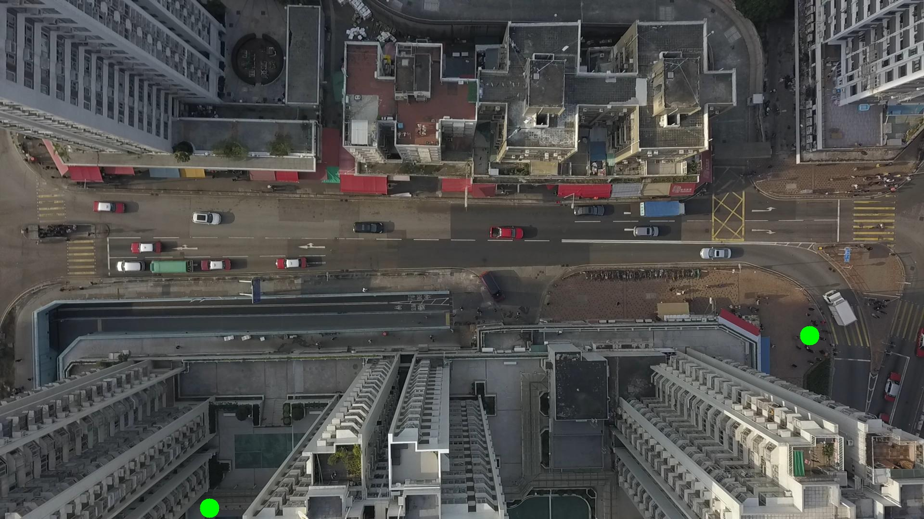

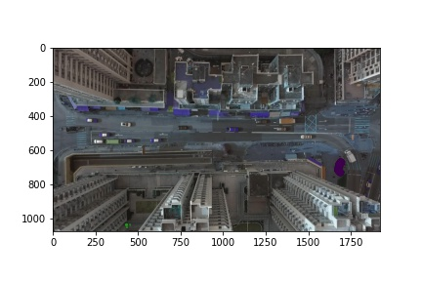

Silhouette metric for img016003.jpg is: 0.8629448142639939

Davies Bouldin metric for img016003.jpg is: 0.09097722583495005

Calinski Harabasz metric for img016003.jpg is: 162256.0253171835

ID 0: (1683, 699)

ID 1: (433, 1059)

ID 2: (1836, 640)

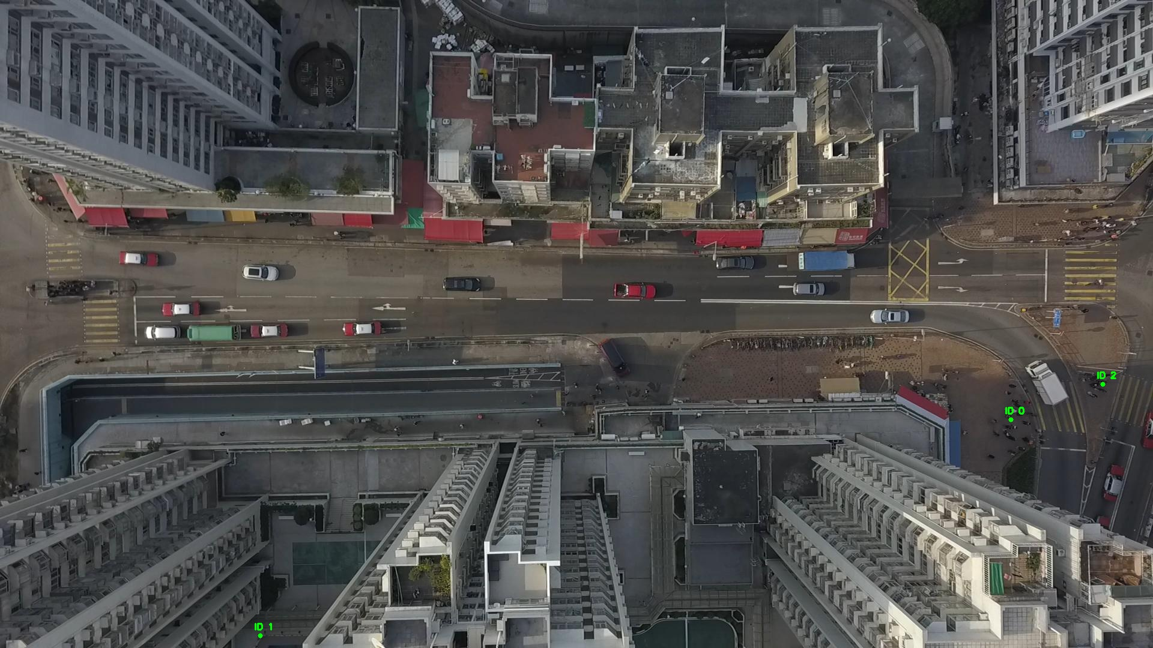

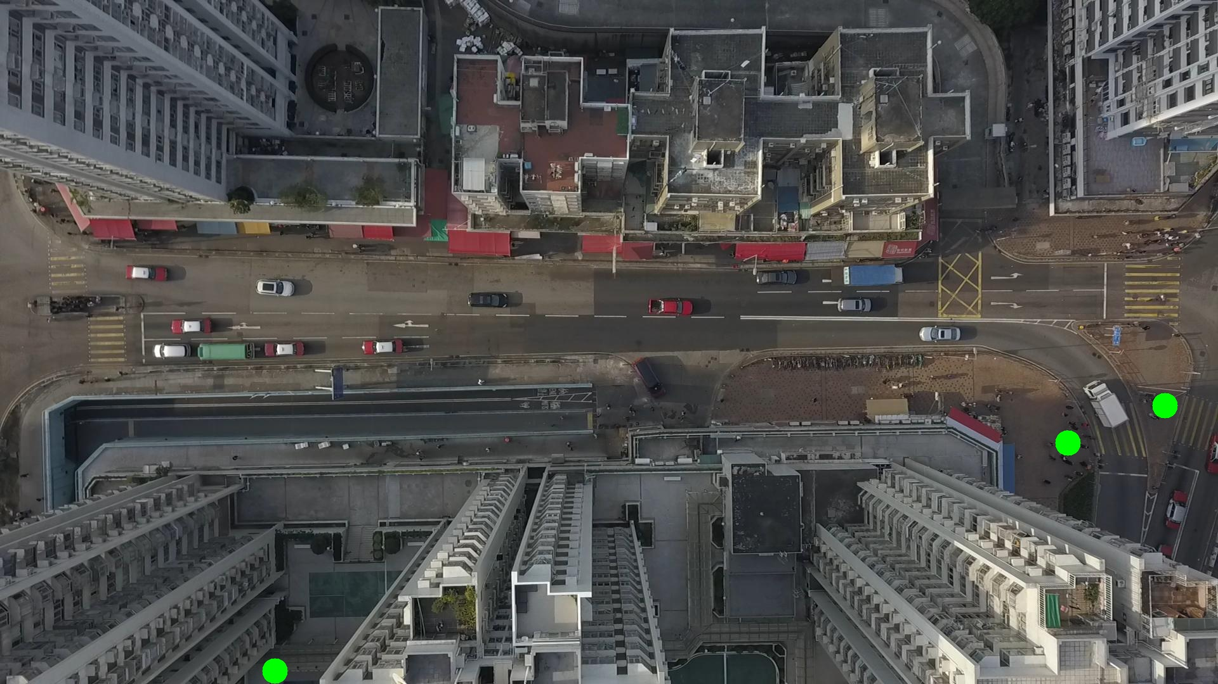

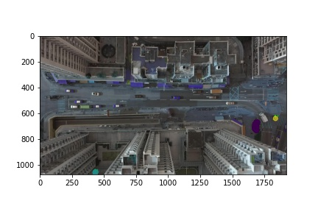

Silhouette metric for img016004.jpg is: 0.982937273426939

Davies Bouldin metric for img016004.jpg is: 0.01750017486614213

Calinski Harabasz metric for img016004.jpg is: 305606.9904821259

ID 0: (1682, 695)

ID 1: (433, 1058)

ID 2: (1836, 640)

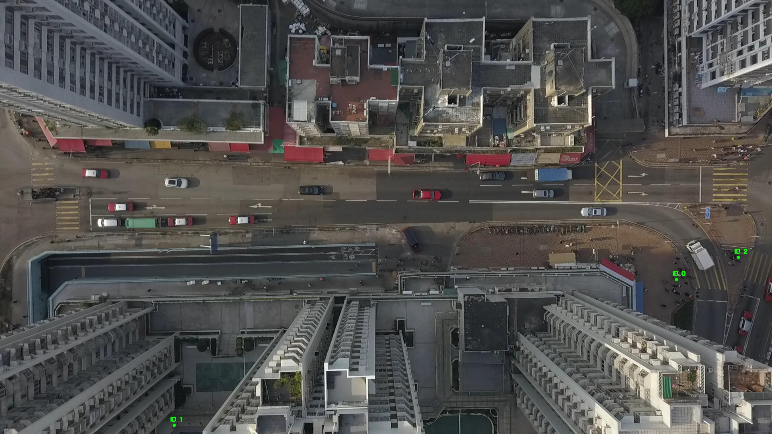

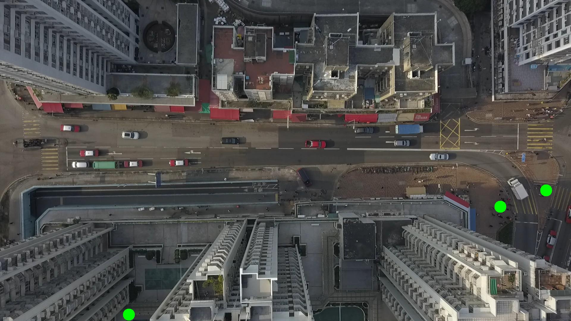

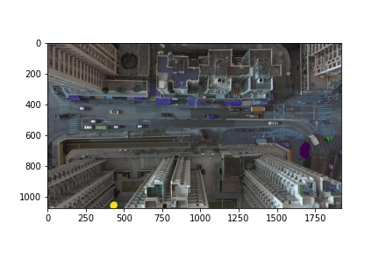

Silhouette metric for img016005.jpg is: 0.9839282537857889

Davies Bouldin metric for img016005.jpg is: 0.01833675899274492

Calinski Harabasz metric for img016005.jpg is: 446256.08970296365

ID 0: (1681, 695)

ID 1: (433, 1057)

ID 2: (1836, 640)

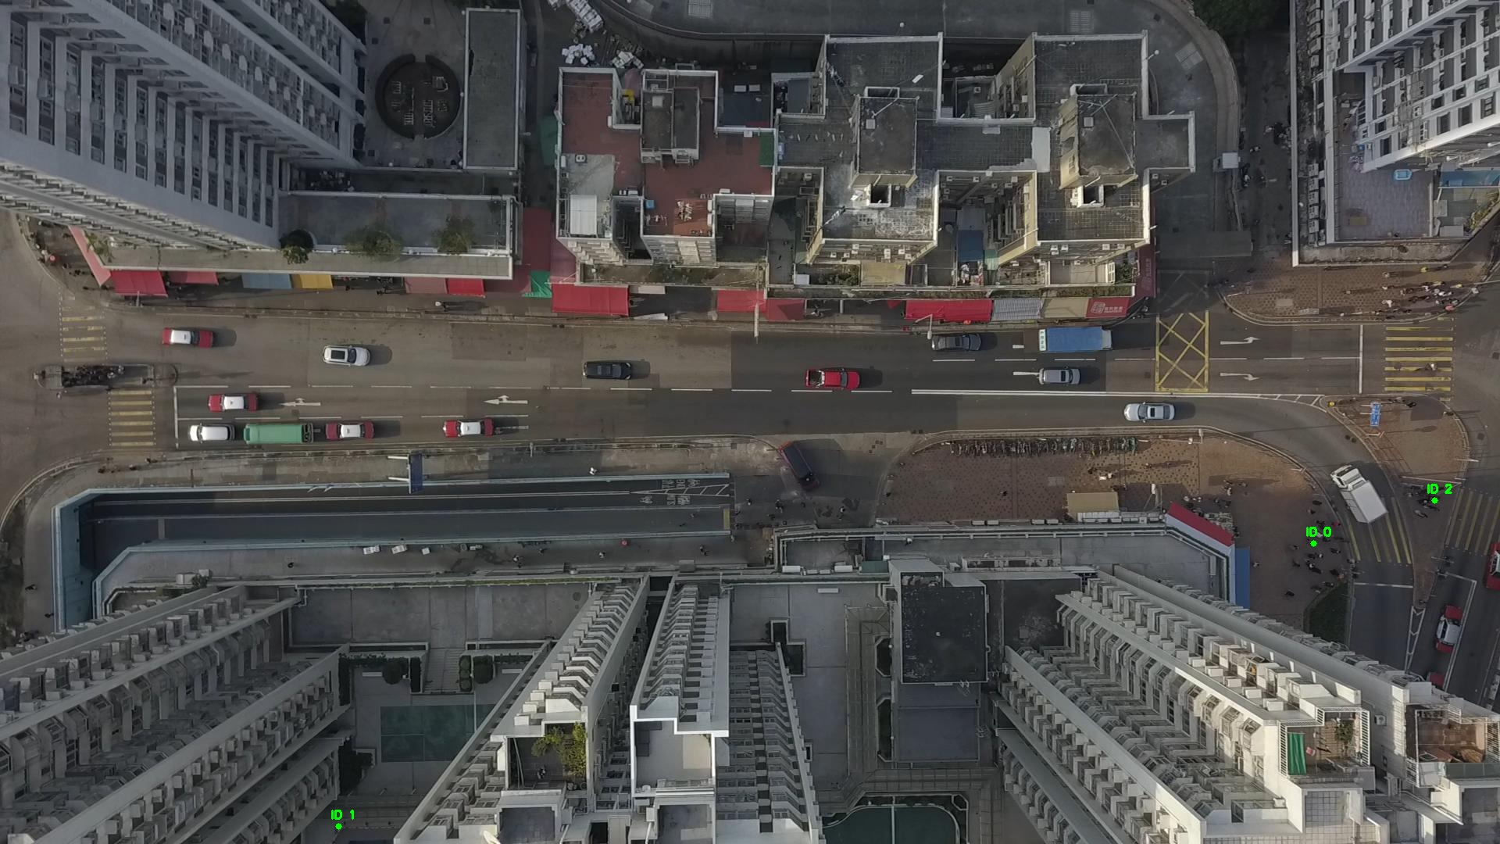

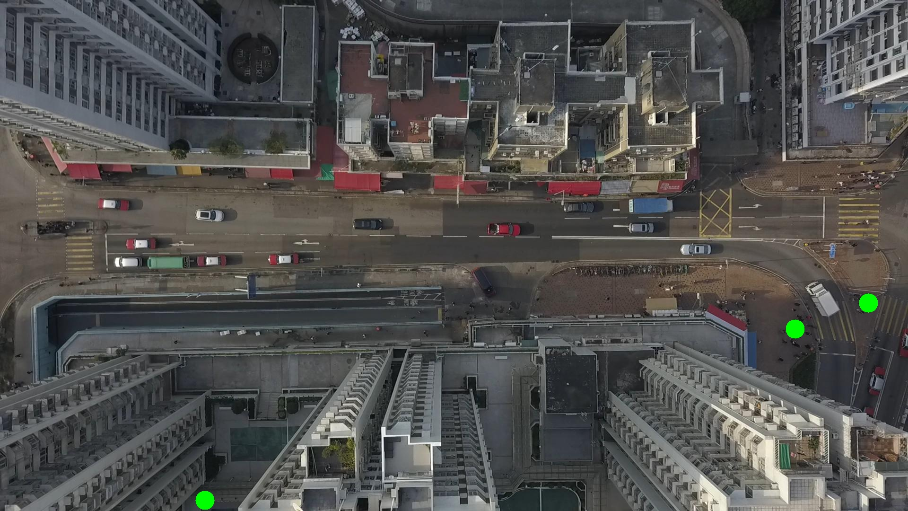

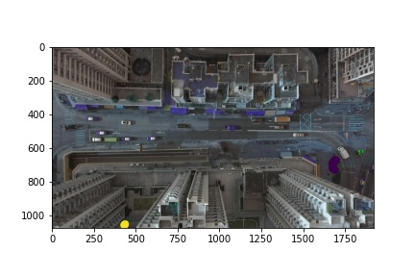

Silhouette metric for img016006.jpg is: 0.8773610409733357

Davies Bouldin metric for img016006.jpg is: 0.10141329100619374

Calinski Harabasz metric for img016006.jpg is: 251417.59220183457

ID 0: (1683, 698)

ID 1: (434, 1057)

ID 2: (1830, 641)

ID 3: (305, 1068)

ID 4: (997, 647)

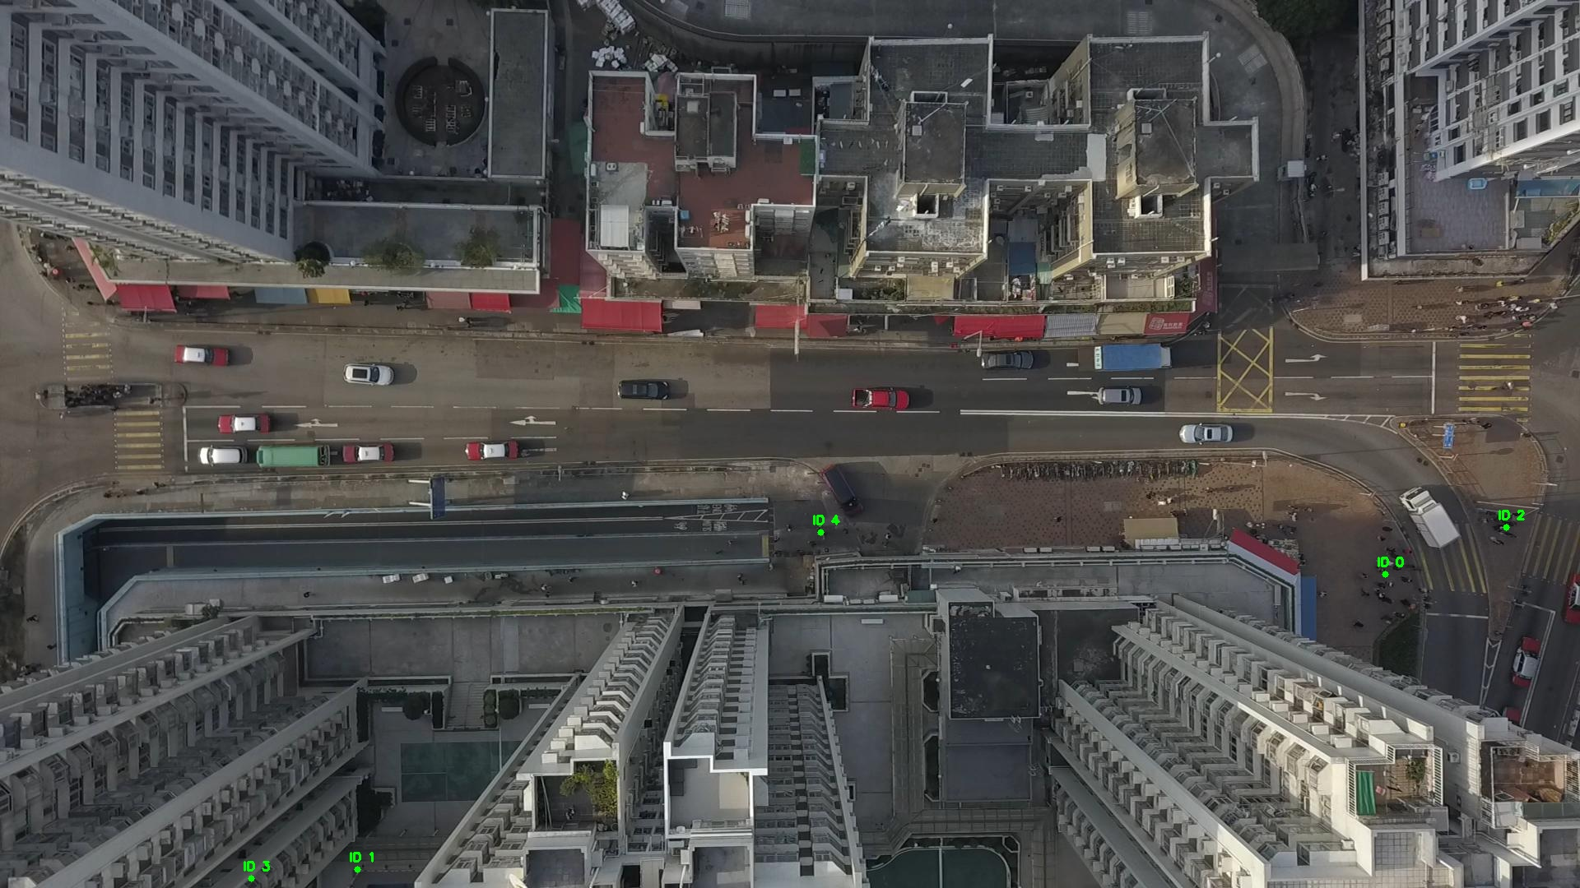

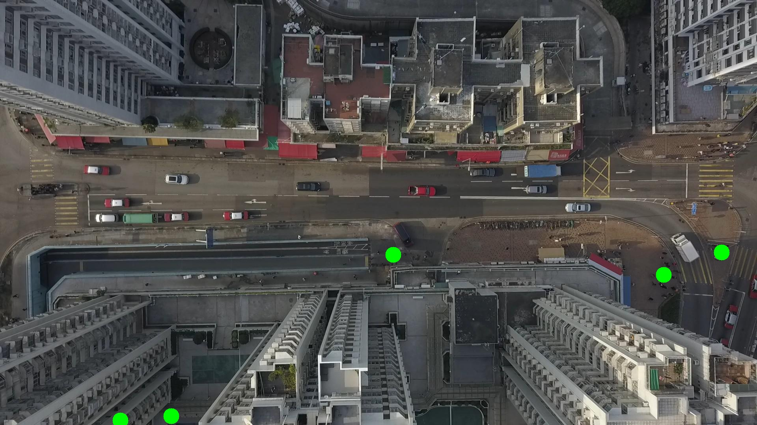

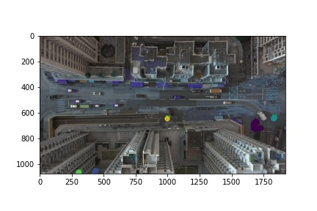

Silhouette metric for img016007.jpg is: 0.8811546070851557

Davies Bouldin metric for img016007.jpg is: 0.09106402280938315

Calinski Harabasz metric for img016007.jpg is: 145227.3753612441

ID 0: (1681, 696)

ID 1: (436, 1057)

ID 2: (1830, 642)

ID 3: (305, 1069)

ID 4: (997, 647)

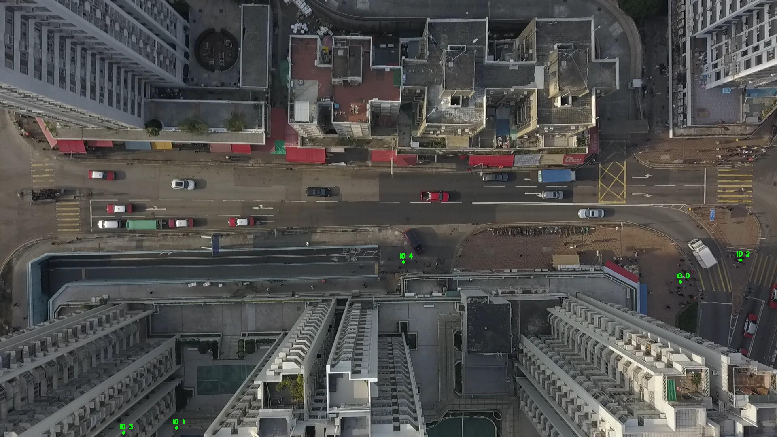

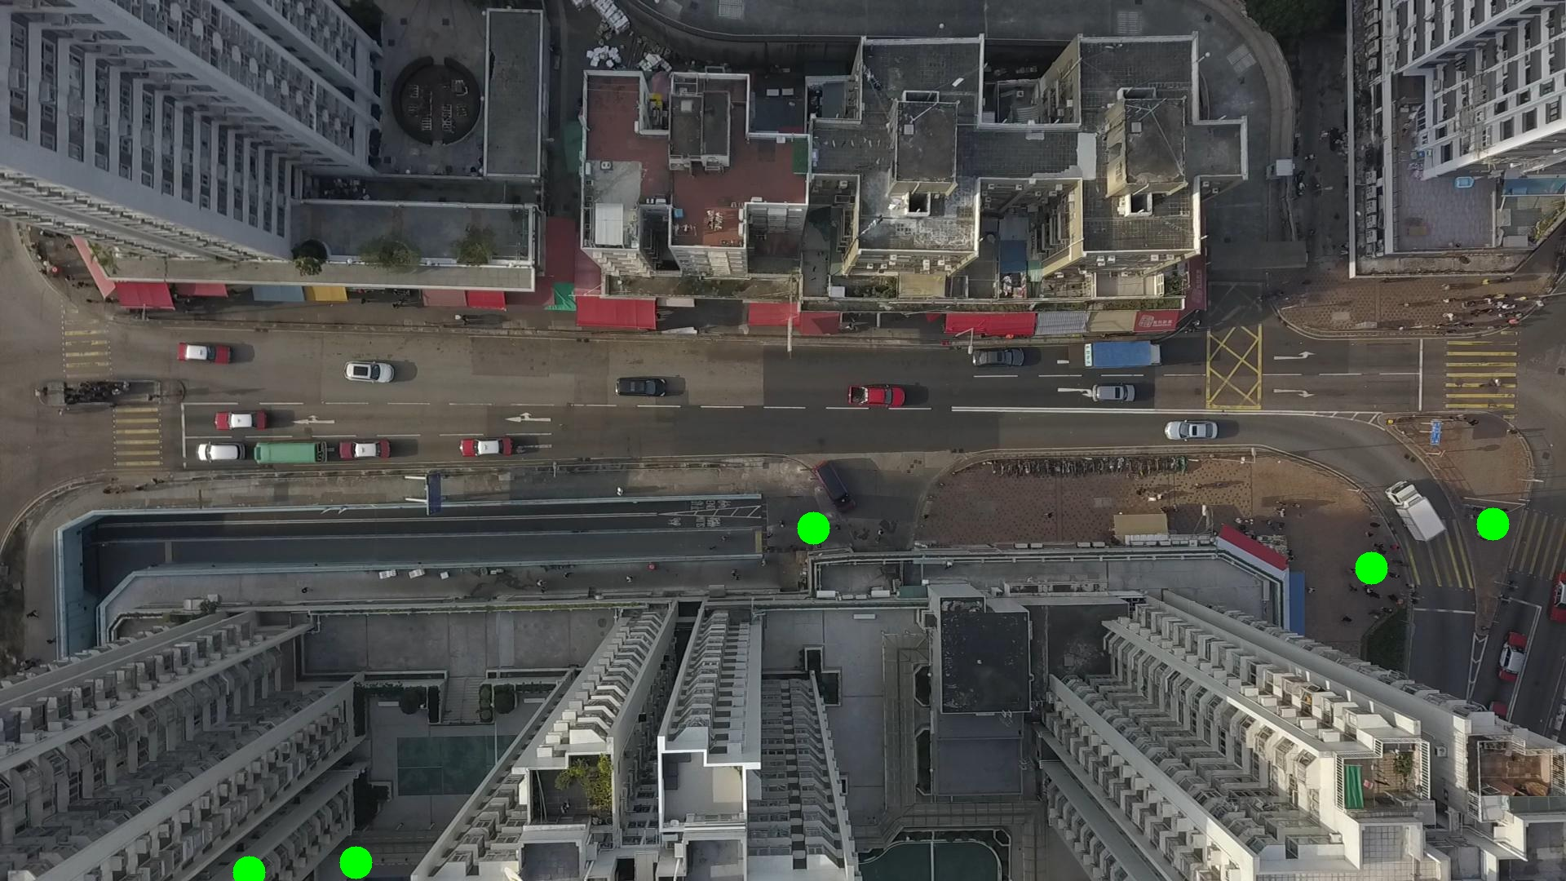

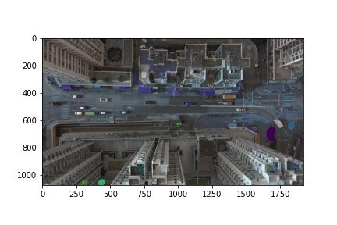

Silhouette metric for img016008.jpg is: 0.8755410600861794

Davies Bouldin metric for img016008.jpg is: 0.11238169701809371

Calinski Harabasz metric for img016008.jpg is: 48112.15195591379

ID 0: (1683, 691)

ID 1: (436, 1057)

ID 2: (1829, 641)

ID 3: (305, 1069)

ID 4: (997, 646)

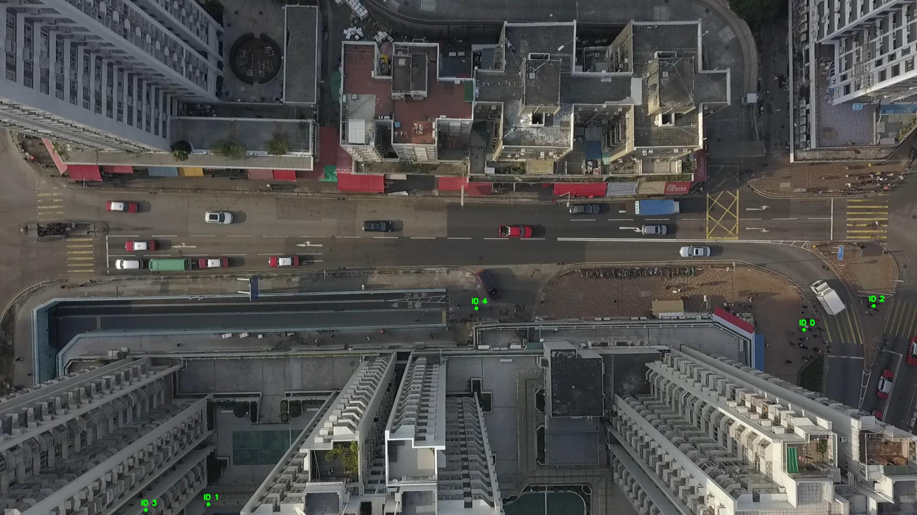

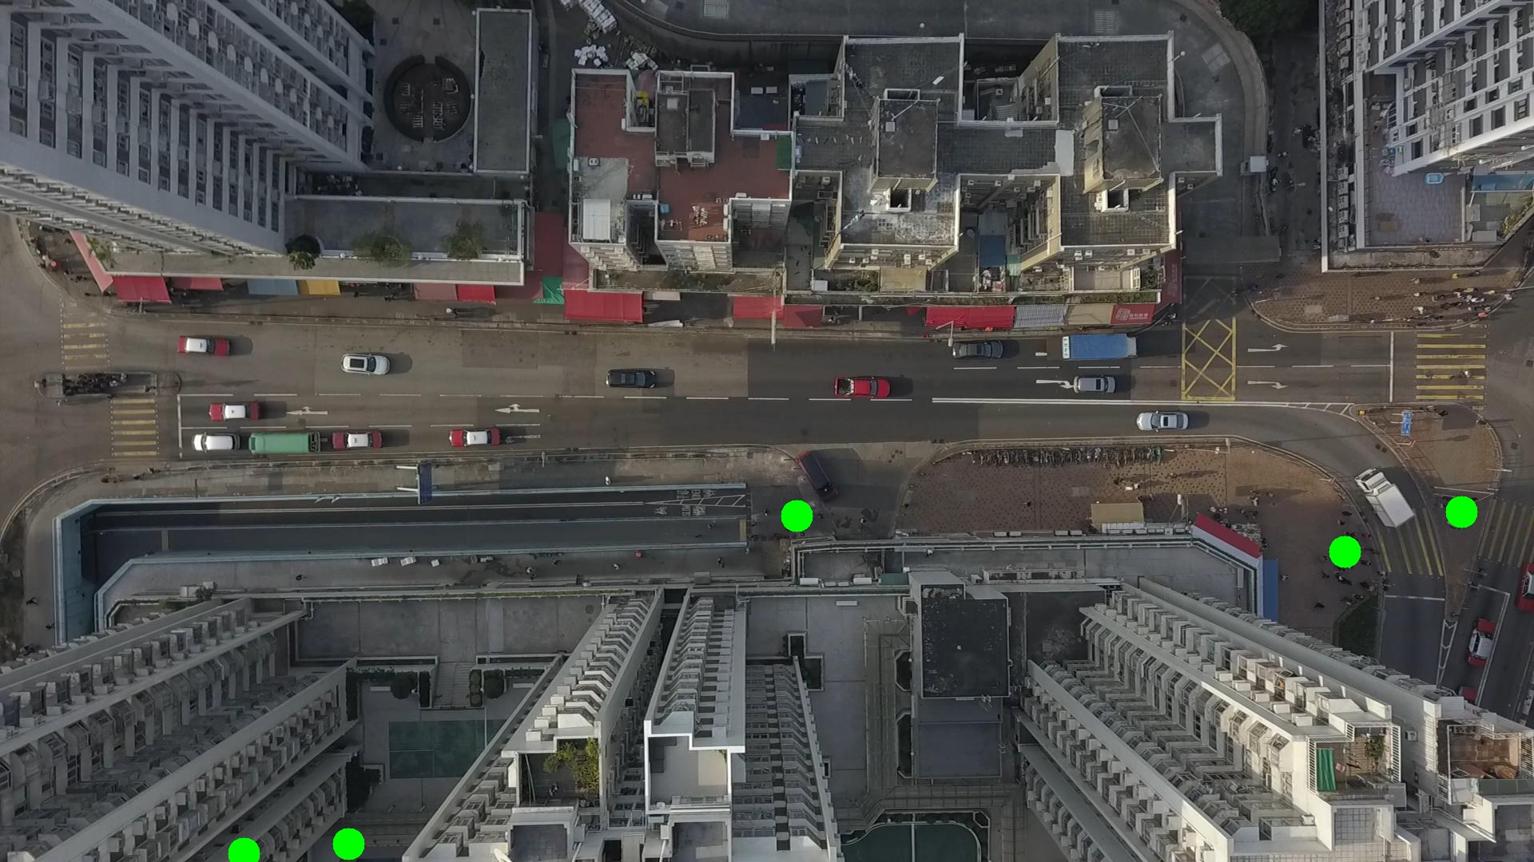

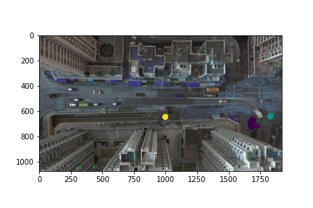

Silhouette metric for img016009.jpg is: 0.9260649043505802

Davies Bouldin metric for img016009.jpg is: 0.06940187885864706

Calinski Harabasz metric for img016009.jpg is: 426827.7291157075

ID 0: (1683, 684)

ID 1: (434, 1059)

ID 2: (1830, 643)

ID 3: (305, 1069)

ID 4: (997, 647)

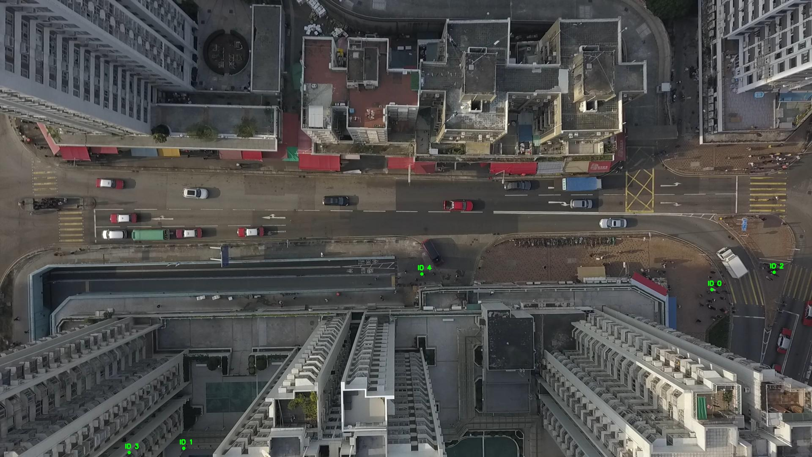

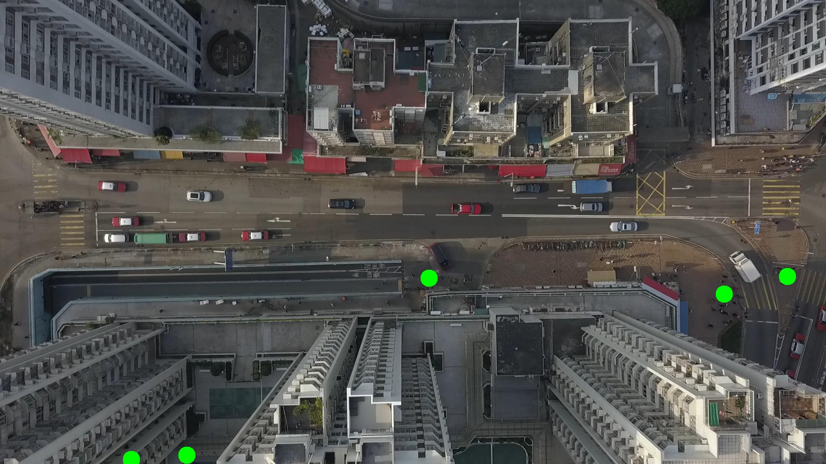

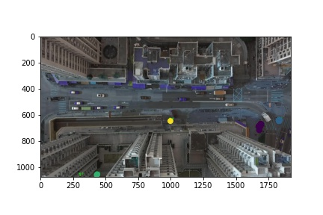

Silhouette metric for img016010.jpg is: 0.9164783817430053

Davies Bouldin metric for img016010.jpg is: 0.11495406884514568

Calinski Harabasz metric for img016010.jpg is: 21005.896946394834

ID 0: (1684, 683)

ID 1: (434, 1059)

ID 2: (1830, 643)

ID 3: (305, 1069)

ID 4: (997, 647)

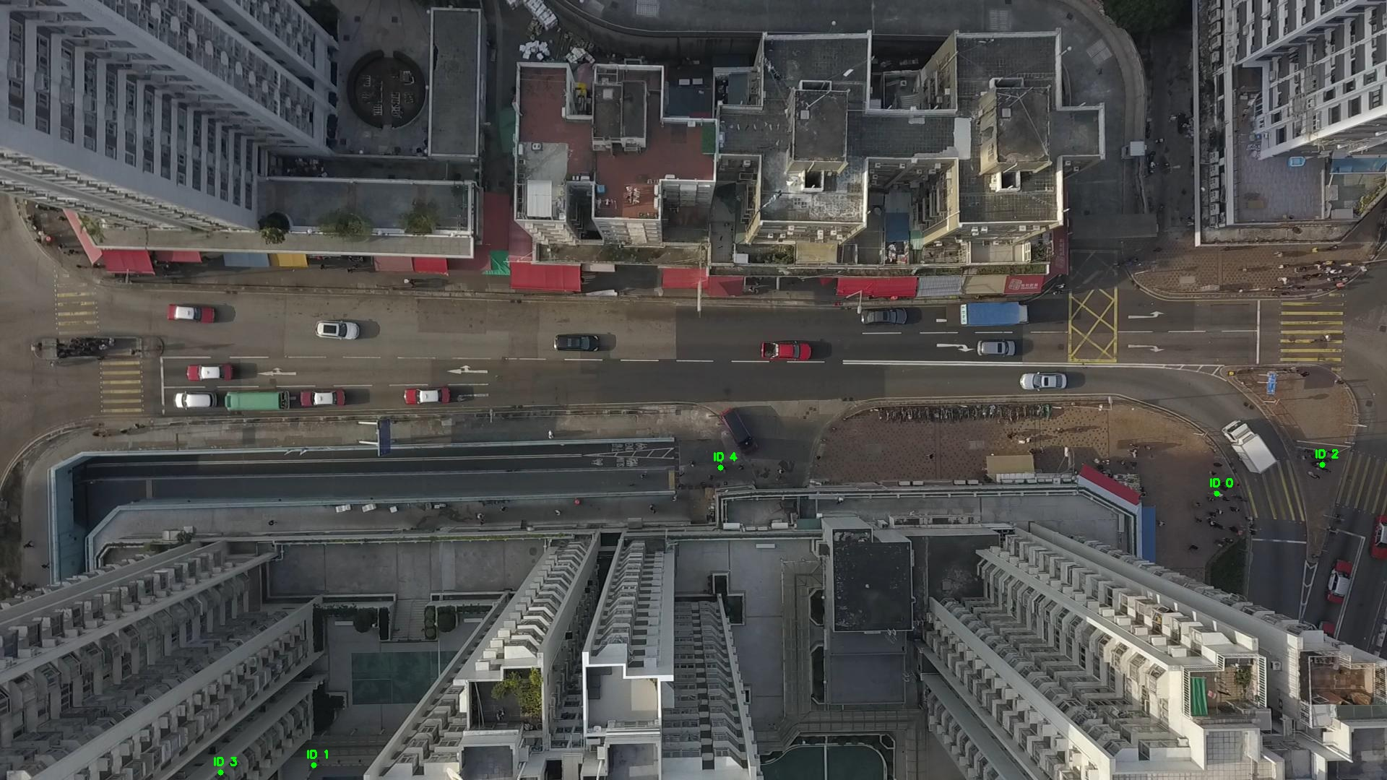

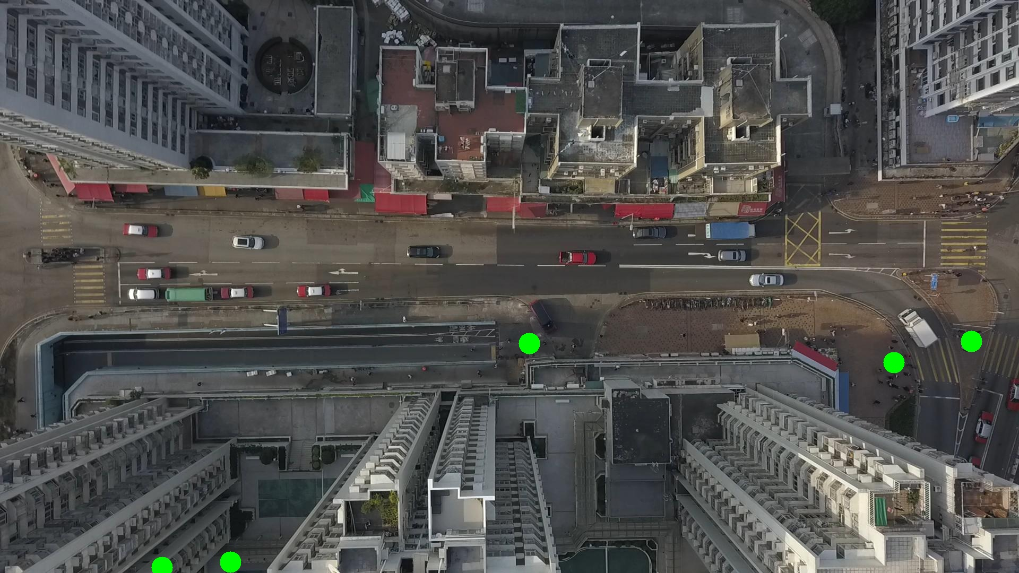

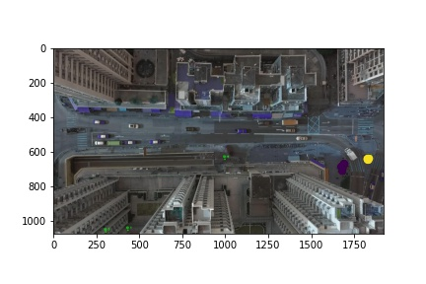

Silhouette metric for img016011.jpg is: 0.9355138542845738

Davies Bouldin metric for img016011.jpg is: 0.09861849729665532

Calinski Harabasz metric for img016011.jpg is: 35122.243533626905

ID 0: (1687, 677)

ID 1: (434, 1059)

ID 2: (1831, 642)

ID 3: (305, 1069)

ID 4: (997, 647)

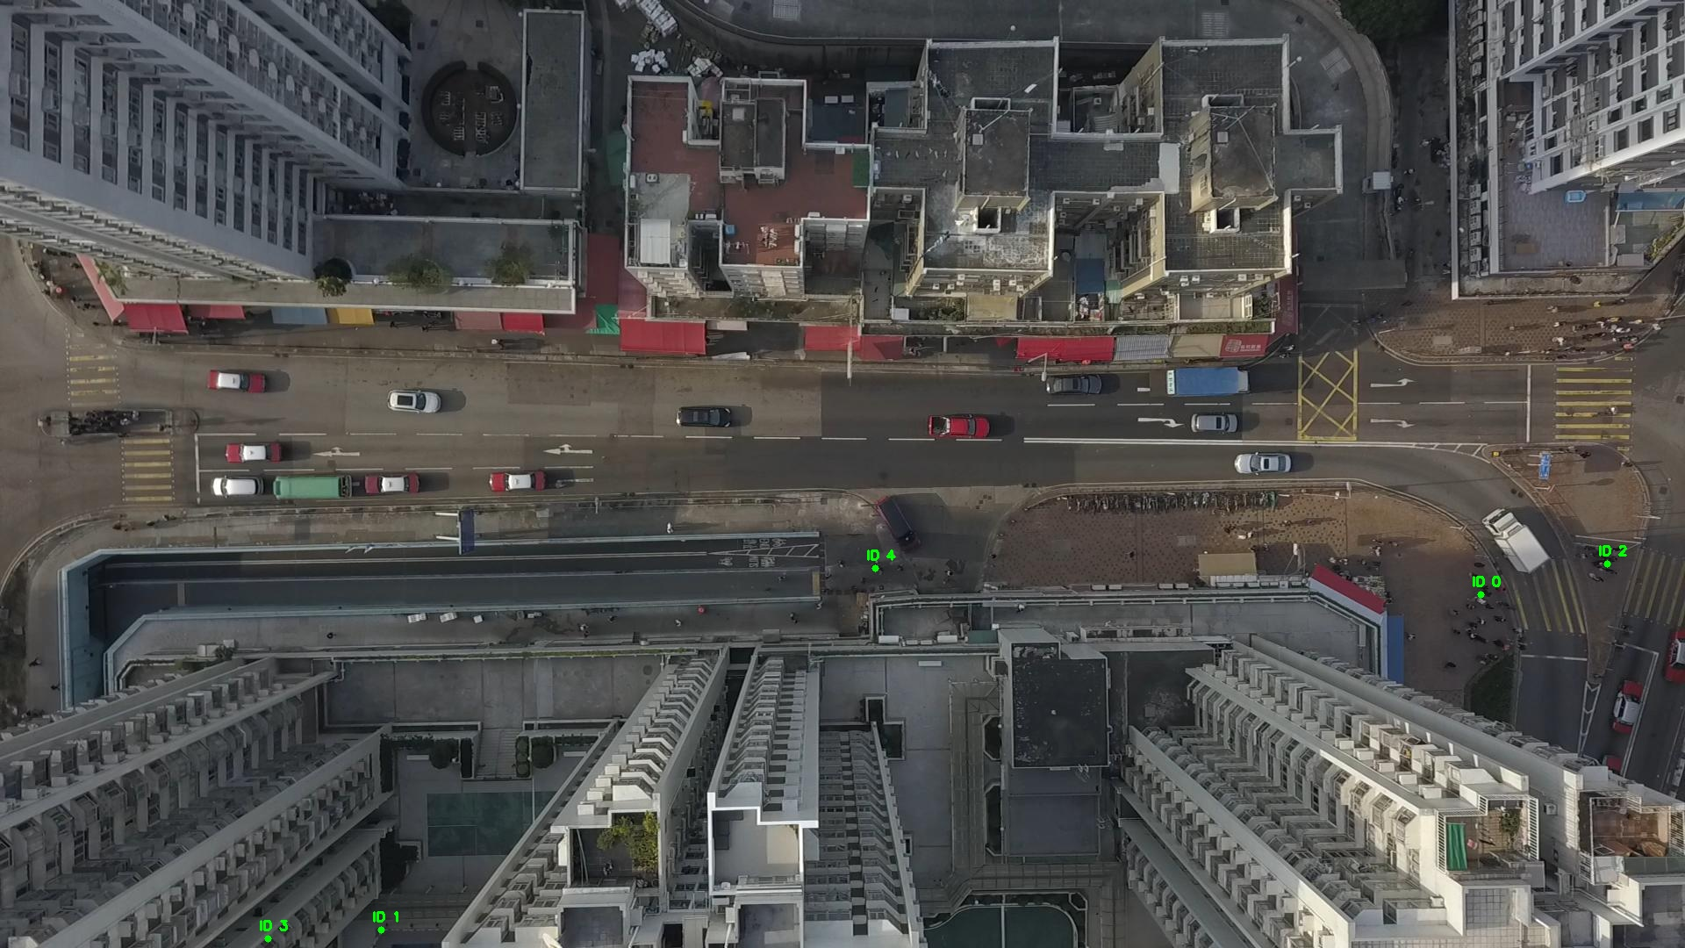

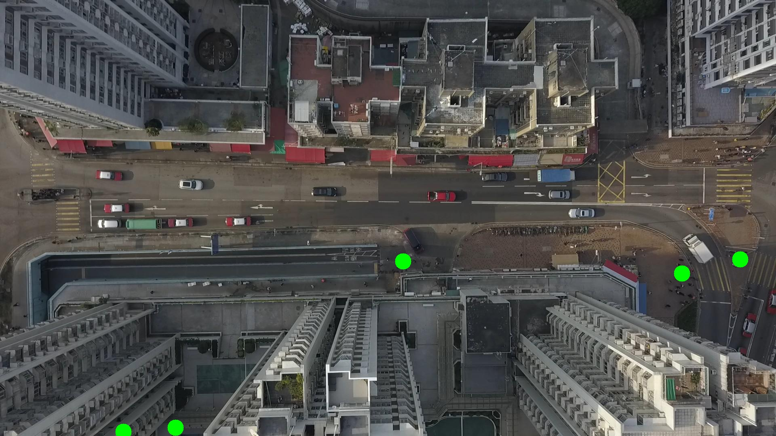

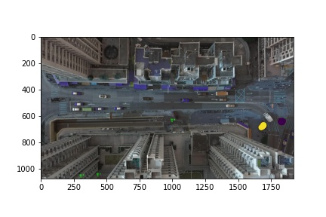

Silhouette metric for img016012.jpg is: 0.9510876013207763

Davies Bouldin metric for img016012.jpg is: 0.06515451207879945

Calinski Harabasz metric for img016012.jpg is: 16600.790809270122

ID 0: (1690, 674)

ID 1: (434, 1059)

ID 2: (1827, 645)

ID 3: (305, 1069)

ID 4: (997, 647)

